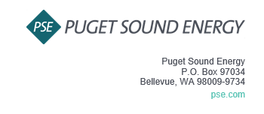
Notice of Customer Meeting for the 2024 PSE OATT Formula Rate Annual Update
Puget Sound Energy, Inc. (PSE) invites you to attend PSE’s Customer Meeting for the 2024 Annual Update to the PSE OATT Formula Rate. The Customer Meeting is an additional opportunity for Interested Parties to obtain information about the Annual Update.
The Customer Meeting is scheduled for July 16th, 2023 at 9:00 am PST. The meeting will be held via Microsoft Teams. The Teams information is as follows (Cntl+Click to follow the link):
Join the meeting now
Meeting ID: 271 551 617 919
Passcode: jVKwrq

Dial in by phone
+1 323-484-5815,,729828232# United States, Los Angeles
Find a local number
Phone conference ID: 729 828 232#

If you have any questions, please contact Lynn Dillender at lynn.dillender@pse.com.
Sincerely,
Puget Sound Energy, Inc.

Lynn Dillender
Regulatory Compliance Consultant

