|  |
| --- |
| *2024 Distributed Solar and Storage Resources RFP:* |
| Exhibit I. Resources |
|  |

NoBar_StdDark_NoTag_RGB

|  |
| --- |
|  |

Resources

The purpose of Exhibit I is to give respondents to the DSS RFP resources to help understand the context in which PSE is acquiring DERs by providing recent regulatory filings and information on PSE’s distribution system.

Regulatory Filings and Information

* PSE’s 2023 Electric Progress Report ([link](https://www.pse.com/en/IRP/Past-IRPs/2023-IRP))
* PSE’s 2023 Distributed Solar and Storage Request for Proposals ([link](https://www.pse.com/en/pages/energy-supply/acquiring-energy/2023-Distributed-Solar-and-Storage-RFP))
* PSE’s 2021 Clean Energy Implementation Plan ([link](https://www.cleanenergyplan.pse.com/ceip-documents))
  + PSE’s 2023 Biennial CEIP update ([link](https://www.pse.com/-/media/PDFs/CEIP/2023/001_BU23_Chapters_Final.pdf))
* CETA Definition of Highly Impacted Community ([link](https://www.doh.wa.gov/DataandStatisticalReports/WashingtonTrackingNetworkWTN/ClimateProjections/CleanEnergyTransformationAct))

PSE Distribution System Information

* PSE is updating its Hosting Capacity Map, but the latest version of the map can be found here [link](https://pugetsoundenergy.maps.arcgis.com/apps/webappviewer/index.html?id=980fc190ffd648489a492f8363a1d2cc).
  + A recent filter added to the HCA is the DER Priority – Yes layer, which highlights all the feeders that would benefit from a DER. PSE is providing additional points to proposals with projects interconnecting to these strategic feeders. Below is a snippet of the layer list and be sure to uncheck the Hosting Capacity layer in order to see the DER Priority – Yes layer.

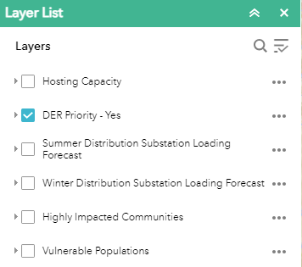

* + Another important metric to note is the DER in Queue value, which is provided on a table whenever you click on a feeder. This metric provides the total MW amount of DERs that are currently in the interconnection queue to be added to that feeder. If a feeder is projected to be over saturated with DERs it creates additional costs, delays and risks to any project seeking to connect to that congested feeder. PSE will deduct points from proposals with any projects looking to interconnect to feeders with DERs currently in queue. Below is a specific example of a problematic feeder at Dieringer where the current DERs in queue are exceeding what the feeder could host.

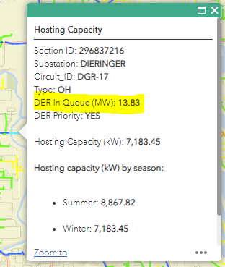

* The Oasis portal where all technical specifications can be found here at [link](http://www.oasis.oati.com/psei/index.html).
* The Technical Interconnection and Interoperability Requirements for Distributed Energy Resources (≤ 34.5kV and ≤ 10 MVA), which includes details on Virtual Power Plant integration requirements, can be found here at [link](https://www.oasis.oati.com/woa/docs/PSEI/PSEIdocs/Technical_Interconnection_and_Interoperability_Requirements__(TIIR)_for_Non_Jurisdictional_Distributed_Energy_Resources_160.70.pdf).
* The portal to complete a Schedule 152 application can be found through the PowerClerk portal at [link](https://www.pse.com/green-options/Renewable-Energy-Programs/distributed-renewables?utm_source=direct&utm_medium=shorturl&utm_campaign=renew-dr&sc_camp=ECA3C6DA7BF344EDD4CFD67D2D420856).