2024 Distributed Solar and Storage Resources RFP:
Exhibit C. BESS Requirements

Key BESS Requirements
Battery Energy Storage System submittals for the DSS RFP must adhere to the requirements listed below and if certain standards cannot be met, the Respondent will need to address them to PSE. If the project is selected to proceed, further information in regards to study reports, calculations, inverter behavior, battery characteristics, etc... shall be requested for analysis as PSE moves forward with its study process.
Requirements
PSE’s key requirements for BESS projects are bulleted below, with details provided in the following paragraphs.
- Seismic
- Physical Characteristics
- Fire Protection
- Site Controller
- Remote Operations
Seismic
    - The structural and nonstructural components of all enclosures, free standing structures, and structural equipment supports shall be designed and constructed to withstand the effects of earthquake motions and seismic loading in accordance with the requirements of the State of Washington Building Code and ASCE 7-16 with supplements No. 1 & 2, and adhering to the site specific geotechnical report provided by PSE with the following parameters:
      - Risk Category IV
      - Seismic Design Category D
      - Site Soil Class D, unless otherwise determined by the Geotechnical Engineer
      - Importance Factor is 1.5
    - All material, methods and equipment shall be designed to the ‘High Seismic Qualification Level’ in accordance with IEEE 693 Standard.
- Supplier shall provide typical anchorage drawings and indicate if anchorage is included in their scope of supply

Physical Characteristics
The BESS shall meet all applicable Occupational Safety and Health Administration (OSHA), National Electric Code (NEC), National Electrical Safety Code (NESC) IEEE, ANSI, and National Fire Protection Association (NFPA) requirements for electrical and fire safety.
The BESS shall be designed to minimize footprint and volume. The BESS may also be designed to include subsurface components or modules, provided relevant operating and environmental factors normally addressed for submersible equipment are considered to assure full life-cycle performance requirements are met.
The BESS components located outdoors shall be contained within weatherproof, tamper resistant, metal enclosures suitable for mounting outdoors on concrete foundations with a minimum NEMA 3R rating.
The enclosures shall be rust-resistant.
Any enclosures shall be dust tight to at least the NEMA 3R rating, except as designed to allow forced air exchange with the atmosphere. Screen vents with metal screens to prevent ingress of insects and rodents. Plug conduits with duct seal for same as well as water ingress.
The BESS shall be designed to operate with minimal maintenance for the specified life of the Project. A nameplate shall be provided including:
- Manufacturer Name
- Connection diagram
- BESS ratings; Power, energy, voltage, BIL
- Specimen data; serial number, date of manufacture
- The nameplate shall meet the requirements of IEEE C57.12.00

All necessary safety signs and warnings as described in ANSI Z535-2002 (entire series from Z535.1 through Z535.6) shall be included on the building, shelter or each enclosure. All necessary signs and warnings for identification of hazardous materials as described in NFPA 704 shall be included on the building, shelter or each enclosure. All necessary signs and warnings as required by CFC 608, as applicable, shall be included.

Fire Protection
The Supplier shall provide fire protection system for the complete BESS system in accordance with NFPA 855 “Standard for the Installation of Stationary Energy Storage Systems” and the latest approved revision of the applicable local fire protection codes. All designs shall include a Hazard Mitigation Analysis, (HMA). All HMA’s shall consist of equipment-specific Failure Mode and Effects Analysis (FMEA) and site-specific Fire Risk Assessment (FRA). All designs shall have the approval of the AHJ. State and local laws, codes, and/or regulations specific to BESS shall apply.
The Supplier shall comply with NFPA coordination, design, installation, commissioning, testing, training and startup requirements. This shall include all other requirements as outlined in this specification. Fire Protection system design shall include, but not be limited to, the following:
- The Supplier shall possess a completed Large Scale Fire Testing of the proposed BESS in accordance with UL 9540A as required by the NFPA 855 Code. The supplier shall provide the approved test results along with the required separation distances per the testing completed.
- The Supplier shall provide the competed Hazard Mitigation Analysis for the proposed BESS as required by Section 4.14 of the NFPA 855 Code.
- The battery container design shall be in accordance with NFPA requirements for location, separation, materials of construction, ventilation, smoke or flammable conditions detection, fire suppression, communications/alarms, training, commissioning, permitting, and documentation.
- The Supplier shall perform an explosion study based on data from UL9540A testing to develop the Explosion Control mitigation design. The Supplier shall provide all design data used in the design.
- Supplier will provide the potential combustion products and quantities for the batteries selected to be used with the BESS system.
- The Supplier shall provide a price for a lithium ion battery fault detector utilizing an off-gas sensing system that will detect off-gassing at the cell level. This system shall be integrated into the Supplier’s control system and/or site controller.

Site Controller (SC)
The BESS shall include all necessary software applications and supporting hardware required to meet the specified functional requirements. Software algorithms, external data input capabilities, and user interfaces shall provide for specified variable input or set point values, as well as external data value streams required from the Owner’s Local Area Controller directing the BESS operations.
The BESS shall include the necessary communication and telemetry hardware, and support communications protocols, to effectively provide the required services. No single mode of failure shall result in loss of power to the control and data acquisition module. The control shall include provisions for an orderly and safe shutdown in the absence of utility power.
The SC shall use DNP/IP, NGVL, IEC 61850 MMS/Goose protocol to interface with Owner's Local Area Controller. All passwords and settings shall be turned over to the Owner after completion of the project The Owner’s preference of a Site Controller is a SEL-3555 RTAC platform on an SEL Axion chassis.

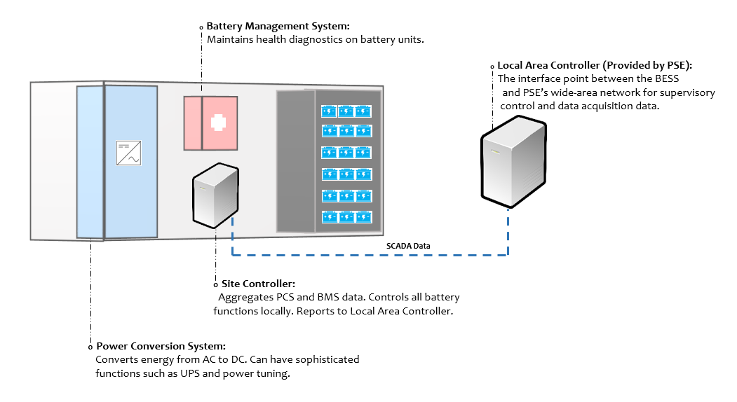

Remote Operations
The BESS shall provide a single interface with which the Owner can communicate. All commands, feedbacks, information, statuses, and alarms from all system components or subsystems (fire suppression and/or HVAC included) shall be conveyed via DNP/IP, NGVL, or IEC 61850 MMS/GOOSE connection from the SC to the Owner’s Local Area Controller. Single interface must have a minimum of four fiber ports and four copper ports or a network switch (Cisco IE4XXXX family) which provides the specified number of ports. Refer to the diagram below to illustrate the control concept.
The SC shall be able to respond to manual commands that are issued remotely by an external supervisory controller using DNP/IP, NGVL, or IEC 61850 MMS/GOOSE protocol. Commands sent to the SC may come from other applications within a larger Distributed Energy Resource hierarchy.
The BESS shall remain functional in the absence or loss of communication from the remote controller. The BESS shall continue its current mode of operation and follow commands for the last available setpoints for a user definable time period (15 minute default). On expiration of the time, the BESS shall maintain current state of charge.
During an interruption to communications, the remote controller will make repeated attempts to re- establish communications at a set time interval (default of 5 minutes). When communications have been re-established, the BESS and remote controller shall make any necessary updates to resume performance.
A “Local/Remote” control function shall be provided as a manual switch so that the operator may allow or inhibit remote commands. The SC shall log the source of each command (i.e., HMI/Operator Name, Remote). The source of the current active command shall also be displayed in the HMI.

Applicable Codes & Standards
ANSI/IEEE C2 | National Electric Safety Code
IEEE 519 | IEEE Recommended Practices and Requirements for harmonic Control in Electrical Power Systems
IEEE 1547-2018 | IEEE Standard for Interconnecting Distributed Resources with Electric Power Systems
IEEE 1547.1 | Standard Conformance Test Procedure for Equipment Interconnecting Distributed Resources with Electric Power Systems
IEEE 1547.2 | Interconnecting Distributed Resources with Electric Power Systems
IEEE 1547.3 | Guide for Monitoring, Information Exchange, and Control of Distributed Resources Interconnected with Electric Power Systems
ANSI Z535 | Product Safety Signs and Labels
ANSI C57/IEEE | Transformer Standards, whenever applicable
ANSI C37/IEEE | Surge withstand capabilities, whenever applicable
UL 1642/IEC 62133 | Applicable sections related to battery cell safety, where applicable
UL 1741 | Standard for Inverters, Converters, Controllers and Interconnection System Equipment for Use with Distributed Energy Resources. Also, Supplemental A is to be included.
NFPA 704 | Standard System for the Identification of the Hazards of Materials for Emergency Response
UL 1778 | Underwriters Laboratory’s Standard for Uninterruptible Power Systems (UPS) for up to 600V A.C.
UL 1973 | Standards for Batteries for Use in Light Electric Rail Applications and Stationary Applications
UL 9540/9540A | Standard for Energy Storage Systems and Equipment
NISTIR 7628 | Guidelines for Smart Grid Cyber Security
NEC | National Electric Code
NESC | National Electric Safety Code
CAA | Clean Air Act and Amendments
CERCLA | Comprehensive Environmental Response, Compensation, and Liability Act of1980
EPA | Environmental Protection Agency regulations
FAA | Federal Aviation Administration regulations
FERC | Federal Energy Regulatory Commission regulations
FPA | Federal Power Act
 | Noise Control Act of 1972
RCRA | Resource Conservation and Recovery Act
SDWA | Safe Drinking Water Act
SWDA | Solid Waste Disposal Act
TSCA | Toxic Substances Control Act
ADA | Americans with Disabilities Act
MBTA | Migratory Bird Treaty Act
CWA | Clean Water Act
ANSI | American National Standards Institute
IEEE | Institute of Electrical and Electronics Engineers
NEMA | National Electrical Manufacturers Association
ASTM | American Society for Testing and Materials
ASME | American Society of Mechanical Engineers
IEEE 1881 | Standard Glossary of Stationary Battery Terminology
IEEE 519 | Recommended Practice and Requirements for Harmonic Control in Electric Power Systems
IEEE 142 | Recommended Practice for Grounding of Industrial and Commercial Power Systems
IEEE 242 | Recommended Practice for Protection and Coordination of Industrial and Commercial Power Systems
IEEE 2030.3 | Standard Test Procedures for Electric Energy Storage Equipment and Systems for Electric Power Systems Applications
EPRI 3002009313 | Energy Storage Integration Council Energy Storage Test Manual 2016
IEEE 1881 | Standard Glossary of Stationary Battery Terminology
IFC 2018 | International Fire Code 2018
MESA | Open Standards for Energy Storage
NFPA 13 | Fire Sprinkler Systems 2019
NFPA 14 | Standard for the Installation of Standpipe and Hose 2019

